Creating an FTR Term Loan through the Dynamic OData Gateway
Test case, evidence pack, and a field-by-field guide to ZFS_T_SLC_DYNGW
Item | Value
Service | ZFS_SB_DYNGATEWAY_O4_API (OData V4, A2X)
System | DS4 / client 100 — DS4_100_NIIF (NIIF Development)
Host | vhnlqds4ap01.sap.niififl.in:44300
Driven from | /IWFND/GW_CLIENT (SAP GUI), via the sap-gui MCP server
User | FS_DEV3
Date | 11 September 2026
Starting state | ZFS_T_SLC_DYNGW emptied by the requester — 0 rows
Result | PASS — FTR transaction 0000000160445 created

1 · The test case
Create a term loan transaction through BAPI_FTR_IRATE_DEALCREATE with the following business parameters, driven entirely over OData — not by running the t-code:
Parameter | Requested value | Sent to the BAPI as
Company code | 1000 | "COMPANY_CODE": "1000"
Product type | 22A (TL – Disbursements) | "PRODUCT_TYPE": "22A"
Transaction type | 100 | "TRANSACTION_TYPE": "100"
Partner | 700000453 | "PARTNER": "0700000453" ← zero-padded, see §9
Start date | 01.01.2026 | "START_TERM": "2026-01-01"
End date | 31.12.2026 | "END_TERM": "2026-12-31"
Amount | 100,000 INR | "NOMINAL_AMOUNT": 100000 (unquoted)
Interest | 10 % fixed | "INTEREST_RATE": 10, "INTEREST_RATE_STRUCTURE": "1"
Interest frequency | monthly | "FREQUENCY_CATEGORY": "3", "FREQUENCY": 1, "FREQUENCY_UNIT": "2"
Valuation class | (not requested — mandatory here) | "VALUATION_CLASS": "0001"

Outcome at a glance:
# | Test case | Expected | Verdict
TC-01 | Call the BAPI before registering it | Refused with message 017, HTTP 200 | PASS
TC-02 | Register it with a REGI batch step | Registry row created | PASS
TC-03 | Dry run, TESTRUN = 'X' | Placeholder \INTERN\, no deal created | PASS
TC-04 | Real create, ExecuteBatch + CommitMode | A real transaction number | PASS
TC-05 | REGI VTBFHA + read it in the same batch | Both steps succeed | PASS
TC-06 | Read the new deal back through the gateway | Exactly 1 row, our deal | PASS

2 · The endpoint — every URL you need
One endpoint, four actions. The action name is the last path segment; what you are calling (function module, table, CDS view, report) goes in the JSON body, never in the URL.
Base:
https://vhnlqds4ap01.sap.niififl.in:44300/sap/opu/odata4/sap/zfs_sb_dyngateway_o4_api/srvd_a2x/sap/zfs_sd_dyngateway/0001
The four actions — all POST, all take the same ten-field body:
POST https://vhnlqds4ap01.sap.niififl.in:44300/sap/opu/odata4/sap/zfs_sb_dyngateway_o4_api/srvd_a2x/sap/zfs_sd_dyngateway/0001/DynGateway/com.sap.gateway.srvd_a2x.zfs_sd_dyngateway.v0001.RunQuery?sap-client=100
POST https://vhnlqds4ap01.sap.niififl.in:44300/sap/opu/odata4/sap/zfs_sb_dyngateway_o4_api/srvd_a2x/sap/zfs_sd_dyngateway/0001/DynGateway/com.sap.gateway.srvd_a2x.zfs_sd_dyngateway.v0001.ExecuteTableCrud?sap-client=100
POST https://vhnlqds4ap01.sap.niififl.in:44300/sap/opu/odata4/sap/zfs_sb_dyngateway_o4_api/srvd_a2x/sap/zfs_sd_dyngateway/0001/DynGateway/com.sap.gateway.srvd_a2x.zfs_sd_dyngateway.v0001.CallFunctionModule?sap-client=100
POST https://vhnlqds4ap01.sap.niififl.in:44300/sap/opu/odata4/sap/zfs_sb_dyngateway_o4_api/srvd_a2x/sap/zfs_sd_dyngateway/0001/DynGateway/com.sap.gateway.srvd_a2x.zfs_sd_dyngateway.v0001.ExecuteBatch?sap-client=100
Inside /IWFND/GW_CLIENT you are already in the system, so you paste only the path (no host). This is what goes in the Request URI field:
/sap/opu/odata4/sap/zfs_sb_dyngateway_o4_api/srvd_a2x/sap/zfs_sd_dyngateway/0001/DynGateway/com.sap.gateway.srvd_a2x.zfs_sd_dyngateway.v0001.CallFunctionModule?sap-client=100
/sap/opu/odata4/sap/zfs_sb_dyngateway_o4_api/srvd_a2x/sap/zfs_sd_dyngateway/0001/DynGateway/com.sap.gateway.srvd_a2x.zfs_sd_dyngateway.v0001.ExecuteBatch?sap-client=100
/sap/opu/odata4/sap/zfs_sb_dyngateway_o4_api/srvd_a2x/sap/zfs_sd_dyngateway/0001/DynGateway/com.sap.gateway.srvd_a2x.zfs_sd_dyngateway.v0001.RunQuery?sap-client=100
Reading the allow-list and the call log is plain OData CRUD on the same entity set — EntryType separates the two kinds of row:
GET /sap/opu/odata4/sap/zfs_sb_dyngateway_o4_api/srvd_a2x/sap/zfs_sd_dyngateway/0001/DynGateway?sap-client=100&$filter=EntryType eq 'R'
GET /sap/opu/odata4/sap/zfs_sb_dyngateway_o4_api/srvd_a2x/sap/zfs_sd_dyngateway/0001/DynGateway?sap-client=100&$filter=EntryType eq 'L'
GET /sap/opu/odata4/sap/zfs_sb_dyngateway_o4_api/srvd_a2x/sap/zfs_sd_dyngateway/0001/DynGateway(<GwUuid>)?sap-client=100
Four ways to get the URL wrong — each fails as something other than what it is:
Mistake | You get | Looks like
srvd instead of srvd_a2x | 403 | an authorisation problem
sap-client omitted | 401 | a wrong password
a key before the action name | 404 | the service is not there
dyngateway instead of DynGateway | 404 | the service is not there
GET instead of POST on an action | 405 | the action does not exist

The entity set, the action names and the namespace are all case-sensitive. Note the 4 in zfs_sb_dyngateway_o4_api — dropping it gives a 404 that reads like an unpublished binding.

3 · Setting up /IWFND/GW_CLIENT
Do this once each time you open the transaction. The Gateway Client fetches and attaches its own CSRF token, so there is no token step and no cookie jar.
# | Field | Set to
1 | Transaction | /IWFND/GW_CLIENT
2 | HTTP Method | POST — the four actions never answer GET
3 | Protocol | HTTP (inside the system) or HTTPS
4 | HTTP Request header grid | content-type = application/json — MANDATORY
5 | Request URI | the path from §2, host omitted
6 | Request body (bottom-left pane) | the JSON from §6, exactly, outer { } included
7 | Execute | F8
8 | Read | ~status_code, then ExecStatus, then the *Json strings

The content-type header is not optional. The body pane defaults to XML, and a JSON payload without that header is parsed as XML and refused with 400 CX_SXML_PARSE_ERROR.

4 · The request body — the same ten fields every time
Send all ten, leaving the ones you are not using as "" or 0.
{ "TargetName":"", "Operation":"", "ImportJson":"", "TablesJson":"",
"FieldsJson":"", "FilterJson":"", "OrderByJson":"", "MaxRows":0,
"StepsJson":"", "CommitMode":"" }
Field | Used by | Meaning
TargetName | single-shot calls | FM / table / CDS view / report name
Operation | ExecuteTableCrud | INSERT | MODIFY | DELETE
 | SUBM step | capture mode SALV | LIST | MEMO | NONE
ImportJson | CallFunctionModule | {"PARAM":value,…} — the FM's IMPORTING
 | ExecuteTableCrud | [{row},{row}] — rows to write
TablesJson | CallFunctionModule | {"TAB":[…]} — TABLES parameters
FieldsJson | RunQuery | ["COL_A","COL_B"]
FilterJson | RunQuery | [{"Field":…,"Op":…,"Low":…,"High":…}]
OrderByJson | RunQuery | [{"Field":…,"Descending":true}]
MaxRows | RunQuery, SUBM | row cap, ceilinged by the registry
StepsJson | ExecuteBatch | ordered array of steps
CommitMode | ExecuteBatch | AUTO (default) | ALWAYS | NEVER

4.1 · The response
{ "GwUuid":"…", "ExecStatus":"S", "MessageText":"…",
"ExportJson":"…", "TablesJson":"…", "RowsJson":"…",
"ResultCount":0, "DurationMs":0 }
Field | Meaning
ExecStatus | S = dispatched · E = refused or failed
MessageText | the reason, from message class ZFS_TRM_MSG
ExportJson | CallFunctionModule → the FM's EXPORTING parameters
TablesJson | CallFunctionModule → TABLES after the call (this is where RETURN is)
RowsJson | RunQuery → the rows · ExecuteBatch → the per-step array
ResultCount | rows returned / affected / steps run
DurationMs | server-side time
GwUuid | key of the call-log row — read the whole call back later

ExecStatus reports the DISPATCH, not the business outcome. A BAPI that failed still comes back S with its errors inside RETURN. A refusal is HTTP 200 with ExecStatus='E' — not an HTTP error. Check the field, not the status code.

5 · ZFS_T_SLC_DYNGW — the one table behind everything
One transparent table holds two completely different kinds of row, told apart by ENTRY_TYPE. This is why the same OData entity set both manages the allow-list and exposes the audit trail — it is the same table, filtered.
ENTRY_TYPE | What the row is | Who writes it
R | a registry row — one allow-listed target | you, via POST/PATCH/DELETE or a REGI step
L | a call-log row — one dispatch that was attempted | the gateway itself, never you

Delivery class A (application data): these rows are DATA, not repository content, so they do NOT travel with a transport. A freshly imported system answers 017 to everything until targets are registered on it.

5.1 · Every field, and what it is for
All 38 fields of the table, in DDIC order. The "Used by" column says which kind of row the field is meaningful on — several are only ever filled on one of the two.
Field | Type | Row | Purpose
CLIENT | MANDT | key | Client. Standard key field.
UUID | SYSUUID_X16 | key | The row's primary key, generated on create. For a log row this is exactly the GwUuid the response handed back, which is how you read a past call back later.
ENTRY_TYPE | CHAR(1) | both | R = registry row, L = call-log row. The discriminator for the whole table.
TARGET_KIND | CHAR(4) | both | FUNC | TABL | QURY | SUBM on a registry row. On a log row it also takes REGI (a registration step) and BTCH (the parent row of an ExecuteBatch) — neither of which is registrable.
TARGET_NAME | CHAR(30) | both | Function module / table / CDS entity / report name. Exact names only — no wildcards. Blank on a BTCH parent row.
OPERATION | CHAR(10) | both | On a registry row: pins the target to one operation (a TABL operation, or a SUBM capture mode); blank = any. On a REGI log row: INSERT/UPDATE/UPSERT, i.e. what was done to the registry itself.
IS_ACTIVE | CHAR(1) | R | X = callable. Clearing it is an instant kill switch — no transport, no restart, no cache to clear. The very next call answers 017.
ALLOW_READ | CHAR(1) | R | Permission to read. QURY needs it.
ALLOW_WRITE | CHAR(1) | R | Permission to write. TABL write operations need it, and ALL FUNC and ALL SUBM targets need it unconditionally — a function module or a report can do anything its caller may do, so neither can be proved read-only in advance.
CALL_MODE | CHAR(1) | R | FUNC only. R = force DESTINATION 'NONE', L = force local, blank = decide automatically from TFDIR-FMODE.
MAX_ROWS | INT4 | R | Row ceiling the caller cannot exceed; asking for more is refused with 025. 0 means NO ceiling — set it deliberately.
DESCR | CHAR(60) | R | Free text. The place to record why a target is registered and any safe-usage note (e.g. a pinned Operation, or a safe selection width for a SUBM report).
LOG_LEVEL | CHAR(1) | R | A = log all (default), E = errors only, N = none. Stored on the table but deliberately NOT exposed over OData.
REGISTRY_UUID | SYSUUID_X16 | L | On a log row: which allow-list row authorised this call. The join back from the audit trail to the permission that permitted it.
REQUEST_JSON | STRING | L | The request as received. Filled on single-shot rows and on a BTCH parent; EMPTY on a batch child row (see §8.1).
RESPONSE_JSON | STRING | L | The response as sent. Filled on FUNC rows, batch parents and batch children; EMPTY on a single-shot QURY row (see §8.1).
EXEC_STATUS | CHAR(1) | L | S = dispatched, E = refused or failed. Note a refused call IS logged — the table records attempts, not just successes.
MESSAGE_ID | ARBGB | L | Message class — always ZFS_TRM_MSG for gateway messages.
MESSAGE_NO | MSGNR | L | The message number: 017 not registered, 026 executed successfully, 022 invalid JSON, 023 unknown field, 024 bad operator, 025 over the row ceiling, 035 already registered.
MESSAGE_TEXT | CHAR(220) | L | The resolved message text, capped at 220 characters.
ROW_COUNT | INT4 | L | Rows returned or affected, or steps run for a batch. 0 on a FUNC row even for a successful creating BAPI — BAPIs report no row count, so the created key lives in RESPONSE_JSON.
DURATION_MS | INT4 | L | Server-side time for this row's work. On a BTCH parent this is the whole batch; on a child it is that step alone.
EXECUTED_BY | SYUNAME | L | The user the call ran as — the effective authorisation ceiling for what it could do.
EXECUTED_AT | TIMESTAMPL | L | When, to the microsecond.
PARENT_UUID | SYSUUID_X16 | L | On a batch child row: the UUID of its BTCH parent. Not exposed over OData.
STEP_INDEX | INT4 | L | 0 on a single-shot call and on a batch parent; 1..n on batch children. Filter STEP_INDEX = 0 to count calls without double-counting batches. Not exposed over OData.
PHASE | CHAR(1) | L | X marks a batch child row. Not exposed over OData.
ZCREATED_BY | TB_CRUSER | both | Audit: who created the row.
ZCREATED_DATE | TB_DCRDAT | both | Audit: creation date.
ZCREATED_TIME | TB_TCRTIM | both | Audit: creation time.
ZCHANGED_BY | TB_UPUSER | both | Audit: who last changed the row.
ZCHANGED_DATE | TB_DUPDAT | both | Audit: last change date.
ZCHANGED_TIME | TB_TUPTIM | both | Audit: last change time.
LOCAL_CREATED_BY | ABP_CREATION_USER | both | RAP administrative field — managed by the framework.
LOCAL_CREATED_AT | ABP_CREATION_TSTMPL | both | RAP administrative field.
LOCAL_LAST_CHANGED_BY | ABP_LOCINST_LASTCHANGE_USER | both | RAP administrative field.
LOCAL_LAST_CHANGED_AT | ABP_LOCINST_LASTCHANGE_TSTMPL | both | RAP administrative field — the local ETag.
LAST_CHANGED_AT | ABP_LASTCHANGE_TSTMPL | both | RAP administrative field — the total ETag.

The four fields marked "not exposed over OData" — LOG_LEVEL, PARENT_UUID, STEP_INDEX and PHASE — exist on the table but are deliberately left out of the OData projection (ZFS_I_DynGateway). Per-step detail is kept for SE16 and for future reporting without changing the published API contract. Query the table directly if you need them.

5.2 · How a registry row is checked, on every single call
ZCL_FS_SLC_GW_REGISTRY=>resolve runs before anything else happens:
# | Check | If it fails
1 | A row exists for (ENTRY_TYPE='R', TARGET_KIND, TARGET_NAME) with IS_ACTIVE='X' | refused, message 017
2 | If the row pins an OPERATION, the call's operation matches it | refused, message 018
3 | The call's read/write need is covered by ALLOW_READ / ALLOW_WRITE | refused, message 018
4 | Otherwise permitted — MAX_ROWS and LOG_LEVEL travel on into the handler | —

Resolution is buffered per request, not per call: a batch naming the same target five times triggers one SELECT, not five.

6 · The test cases, step by step
Every request below is the exact text pasted into the body pane of /IWFND/GW_CLIENT. They are shown as a single line because that is what goes in the field; a readable expansion of the nested JSON follows each one.

TC-00 · Baseline — the registry is empty
The requester deleted every row of ZFS_T_SLC_DYNGW before this run, so the gateway starts with no permissions at all. SE16 confirms it.
Expected | 0 rows
Actual | SE16: "No table entries found for specified key"
Verdict | PASS

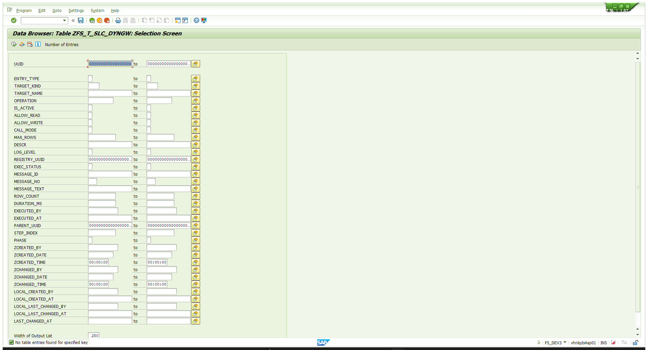
00-baseline-table-empty.png — ZFS_T_SLC_DYNGW is empty. The selection screen also lists every field of the table.

TC-01 · Calling the BAPI before it is registered
Purpose: prove that nothing runs unless an administrator allow-listed it — and that a refusal is a normal HTTP 200 response, not an HTTP error.
Action:
POST /sap/opu/odata4/sap/zfs_sb_dyngateway_o4_api/srvd_a2x/sap/zfs_sd_dyngateway/0001/DynGateway/com.sap.gateway.srvd_a2x.zfs_sd_dyngateway.v0001.CallFunctionModule?sap-client=100
Request body (paste this):
{"TargetName":"BAPI_FTR_IRATE_DEALCREATE","Operation":"","ImportJson":"{\"GENERALCONTRACTDATA\":{\"COMPANY_CODE\":\"1000\",\"PRODUCT_TYPE\":\"22A\",\"TRANSACTION_TYPE\":\"100\",\"PARTNER\":\"0700000453\",\"CONTRACT_DATE\":\"2026-01-01\",\"VALUATION_CLASS\":\"0001\"},\"GENERALCONTRACTDATAX\":{\"COMPANY_CODE\":\"X\",\"PRODUCT_TYPE\":\"X\",\"TRANSACTION_TYPE\":\"X\",\"PARTNER\":\"X\",\"CONTRACT_DATE\":\"X\",\"VALUATION_CLASS\":\"X\"},\"INTERESTRATEINSTRUMENT\":{\"CURRENCY\":\"INR\",\"START_TERM\":\"2026-01-01\",\"END_TERM\":\"2026-12-31\",\"NOMINAL_AMOUNT\":100000,\"INTEREST_RATE_STRUCTURE\":\"1\",\"INTEREST_CONDITION_TYPE\":\"1200\",\"INTEREST_RATE\":10,\"INTEREST_CALC_METH\":\"3\",\"FREQUENCY_CATEGORY\":\"3\",\"FREQUENCY\":1,\"FREQUENCY_UNIT\":\"2\",\"INTEREST_CALENDAR_ID\":\"01\",\"EFFECTIVE_FROM\":\"2026-01-01\",\"REPAY_STRUCTURE\":\"1\",\"REPAY_CONDITION_TYPE\":\"1120\"},\"INTERESTRATEINSTRUMENTX\":{\"CURRENCY\":\"X\",\"START_TERM\":\"X\",\"END_TERM\":\"X\",\"NOMINAL_AMOUNT\":\"X\",\"INTEREST_RATE_STRUCTURE\":\"X\",\"INTEREST_CONDITION_TYPE\":\"X\",\"INTEREST_RATE\":\"X\",\"INTEREST_CALC_METH\":\"X\",\"FREQUENCY_CATEGORY\":\"X\",\"FREQUENCY\":\"X\",\"FREQUENCY_UNIT\":\"X\",\"INTEREST_CALENDAR_ID\":\"X\",\"EFFECTIVE_FROM\":\"X\",\"REPAY_STRUCTURE\":\"X\",\"REPAY_CONDITION_TYPE\":\"X\"},\"TESTRUN\":\"X\"}","TablesJson":"{\"CONDITION\":[],\"CONDITIONX\":[],\"FORMULAVARIABLE\":[],\"SINGLEDATE\":[],\"PAYMENTDETAIL\":[],\"PAYMENTDETAILX\":[],\"ADDFLOW\":[],\"ADDFLOWX\":[],\"MAINFLOW\":[],\"MAINFLOWX\":[],\"RETURN\":[]}","FieldsJson":"","FilterJson":"","OrderByJson":"","MaxRows":0,"StepsJson":"","CommitMode":""}
Expected | HTTP 200, ExecStatus='E', message 017
Actual | HTTP 200 OK · ExecStatus=E · ResultCount=0 · DurationMs=722  MessageText: "Target BAPI_FTR_IRATE_DEALCREATE is not registered for the dynamic gateway"  GwUuid: 5254001f-e7a2-1fd1-abbc-5a2998cc6000
Table effect | 0 rows → 1 row: one ENTRY_TYPE='L' row, TARGET_KIND='FUNC', EXEC_STATUS='E', MESSAGE_NO='017'. A refused call is still logged — the table is an audit of attempts, not of successes.
Verdict | PASS

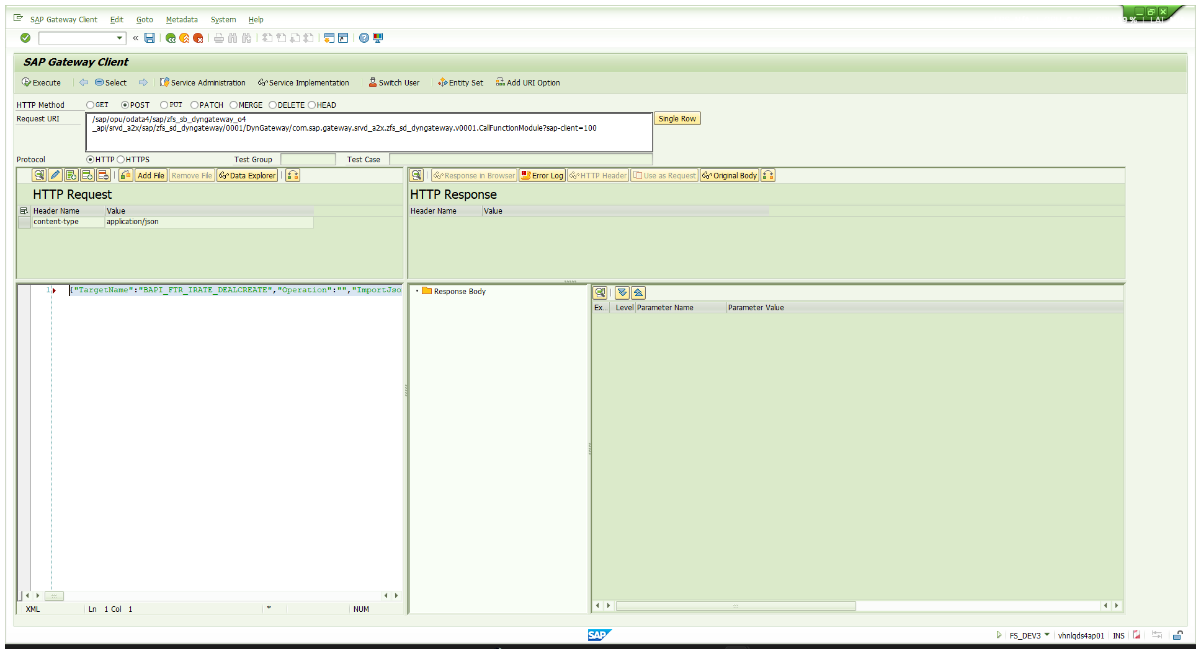
01-TC01-refusal-request.png — TC-01 request — method, URI, content-type header and body
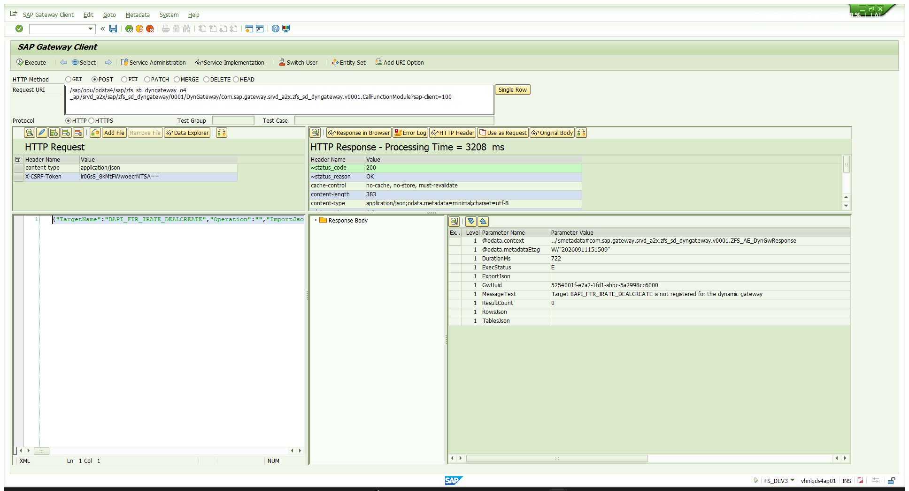
02-TC01-refusal-response-017.png — TC-01 response — status 200, ExecStatus E, message 017. Note the Gateway Client added the X-CSRF-Token itself.

TC-02 · Registering the BAPI with a REGI step
Purpose: register a target without leaving the gateway. REGI is a step kind inside ExecuteBatch — not a registrable target kind — and it exists because allow-list rows do not travel with a transport, so a fresh system otherwise needs one POST per target.
Action:
POST /sap/opu/odata4/sap/zfs_sb_dyngateway_o4_api/srvd_a2x/sap/zfs_sd_dyngateway/0001/DynGateway/com.sap.gateway.srvd_a2x.zfs_sd_dyngateway.v0001.ExecuteBatch?sap-client=100
Request body (paste this):
{"TargetName":"","Operation":"","ImportJson":"","TablesJson":"","FieldsJson":"","FilterJson":"","OrderByJson":"","MaxRows":0,"StepsJson":"[{\"Kind\":\"REGI\",\"TargetName\":\"BAPI_FTR_IRATE_DEALCREATE\",\"Operation\":\"INSERT\",\"ImportJson\":\"{\\\"TargetKind\\\":\\\"FUNC\\\",\\\"Operation\\\":\\\"\\\",\\\"IsActive\\\":\\\"X\\\",\\\"AllowRead\\\":\\\"X\\\",\\\"AllowWrite\\\":\\\"X\\\",\\\"CallMode\\\":\\\"\\\",\\\"MaxRows\\\":0,\\\"Descr\\\":\\\"FTR term loan create - test case 2026-09-11\\\"}\"}]","CommitMode":"AUTO"}
What the nesting means — StepsJson is a string containing steps, and the step's own ImportJson is again a string, so this payload is three levels deep. Expanded:
StepsJson (level 2) =
[
{
"Kind": "REGI",
"TargetName": "BAPI_FTR_IRATE_DEALCREATE",
"Operation": "INSERT",
"ImportJson": "{\"TargetKind\":\"FUNC\",\"Operation\":\"\",\"IsActive\":\"X\",\"AllowRead\":\"X\",\"AllowWrite\":\"X\",\"CallMode\":\"\",\"MaxRows\":0,\"Descr\":\"FTR term loan create - test case 2026-09-11\"}"
}
]
step.ImportJson (level 3) =
{
"TargetKind": "FUNC",
"Operation": "",
"IsActive": "X",
"AllowRead": "X",
"AllowWrite": "X",
"CallMode": "",
"MaxRows": 0,
"Descr": "FTR term loan create - test case 2026-09-11"
}
Two different Operation fields, deliberately: the STEP's Operation (INSERT here) says what to do to the registry row itself; the Operation INSIDE ImportJson would pin the registered target to one operation. INSERT is the default and fails with 035 if the target already exists — widening an existing registration must be typed out as UPDATE, on purpose.
Expected | ExecStatus='S', one registry row created
Actual | HTTP 200 · ExecStatus=S · ResultCount=1 · DurationMs=208  MessageText: "ExecuteBatch executed successfully, 1 row(s) affected"  RowsJson step 1: KIND=REGI, TARGETNAME=BAPI_FTR_IRATE_DEALCREATE, EXECSTATUS=S
Table effect | 1 row → 4 rows. One ExecuteBatch writes THREE rows:  • the registry row itself — ENTRY_TYPE='R', TARGET_KIND='FUNC', IS_ACTIVE='X', ALLOW_WRITE='X'  • a batch PARENT log row — ENTRY_TYPE='L', TARGET_KIND='BTCH', blank TARGET_NAME, STEP_INDEX=0  • a batch CHILD log row — TARGET_KIND='REGI', STEP_INDEX=1, PHASE='X'
Verdict | PASS

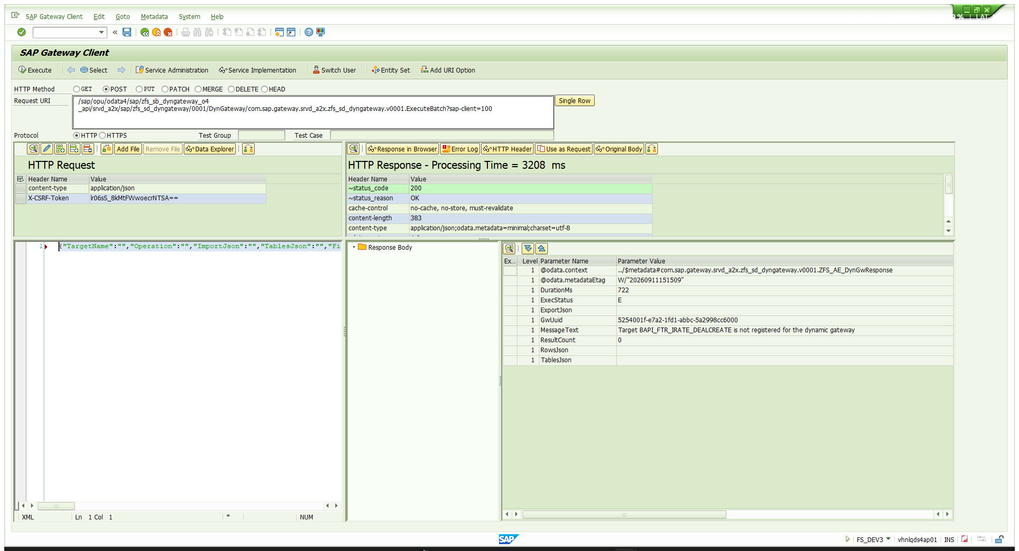
03-TC02-REGI-request.png — TC-02 request — the three-level REGI payload
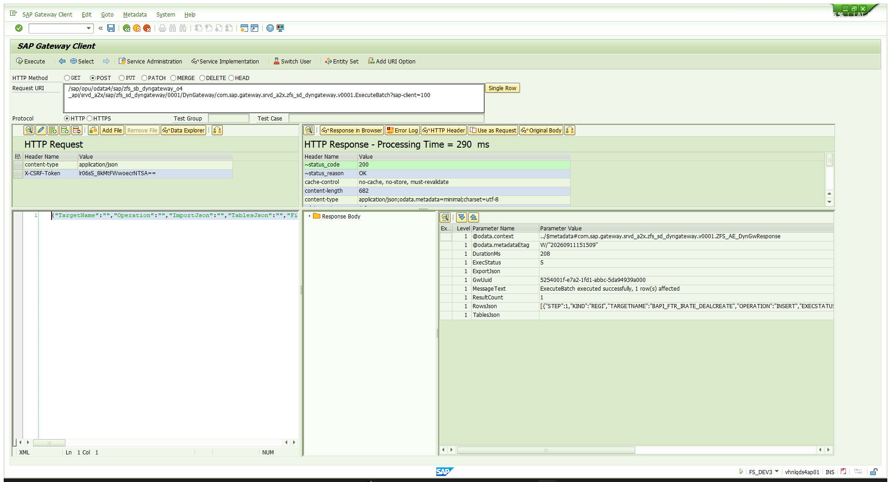
04-TC02-REGI-response.png — TC-02 response — the target is now registered

TC-03 · Dry run with TESTRUN = 'X'
Purpose: validate the whole payload against the BAPI's own checks without creating anything. A successful dry run returns the placeholder \INTERN\ instead of a number.
Action:
POST /sap/opu/odata4/sap/zfs_sb_dyngateway_o4_api/srvd_a2x/sap/zfs_sd_dyngateway/0001/DynGateway/com.sap.gateway.srvd_a2x.zfs_sd_dyngateway.v0001.CallFunctionModule?sap-client=100
Request body (paste this):
{"TargetName":"BAPI_FTR_IRATE_DEALCREATE","Operation":"","ImportJson":"{\"GENERALCONTRACTDATA\":{\"COMPANY_CODE\":\"1000\",\"PRODUCT_TYPE\":\"22A\",\"TRANSACTION_TYPE\":\"100\",\"PARTNER\":\"0700000453\",\"CONTRACT_DATE\":\"2026-01-01\",\"VALUATION_CLASS\":\"0001\"},\"GENERALCONTRACTDATAX\":{\"COMPANY_CODE\":\"X\",\"PRODUCT_TYPE\":\"X\",\"TRANSACTION_TYPE\":\"X\",\"PARTNER\":\"X\",\"CONTRACT_DATE\":\"X\",\"VALUATION_CLASS\":\"X\"},\"INTERESTRATEINSTRUMENT\":{\"CURRENCY\":\"INR\",\"START_TERM\":\"2026-01-01\",\"END_TERM\":\"2026-12-31\",\"NOMINAL_AMOUNT\":100000,\"INTEREST_RATE_STRUCTURE\":\"1\",\"INTEREST_CONDITION_TYPE\":\"1200\",\"INTEREST_RATE\":10,\"INTEREST_CALC_METH\":\"3\",\"FREQUENCY_CATEGORY\":\"3\",\"FREQUENCY\":1,\"FREQUENCY_UNIT\":\"2\",\"INTEREST_CALENDAR_ID\":\"01\",\"EFFECTIVE_FROM\":\"2026-01-01\",\"REPAY_STRUCTURE\":\"1\",\"REPAY_CONDITION_TYPE\":\"1120\"},\"INTERESTRATEINSTRUMENTX\":{\"CURRENCY\":\"X\",\"START_TERM\":\"X\",\"END_TERM\":\"X\",\"NOMINAL_AMOUNT\":\"X\",\"INTEREST_RATE_STRUCTURE\":\"X\",\"INTEREST_CONDITION_TYPE\":\"X\",\"INTEREST_RATE\":\"X\",\"INTEREST_CALC_METH\":\"X\",\"FREQUENCY_CATEGORY\":\"X\",\"FREQUENCY\":\"X\",\"FREQUENCY_UNIT\":\"X\",\"INTEREST_CALENDAR_ID\":\"X\",\"EFFECTIVE_FROM\":\"X\",\"REPAY_STRUCTURE\":\"X\",\"REPAY_CONDITION_TYPE\":\"X\"},\"TESTRUN\":\"X\"}","TablesJson":"{\"CONDITION\":[],\"CONDITIONX\":[],\"FORMULAVARIABLE\":[],\"SINGLEDATE\":[],\"PAYMENTDETAIL\":[],\"PAYMENTDETAILX\":[],\"ADDFLOW\":[],\"ADDFLOWX\":[],\"MAINFLOW\":[],\"MAINFLOWX\":[],\"RETURN\":[]}","FieldsJson":"","FilterJson":"","OrderByJson":"","MaxRows":0,"StepsJson":"","CommitMode":""}
ImportJson expanded:
{
"GENERALCONTRACTDATA": {
"COMPANY_CODE": "1000",
"PRODUCT_TYPE": "22A",
"TRANSACTION_TYPE": "100",
"PARTNER": "0700000453",
"CONTRACT_DATE": "2026-01-01",
"VALUATION_CLASS": "0001"
},
"GENERALCONTRACTDATAX": {
"COMPANY_CODE": "X",
"PRODUCT_TYPE": "X",
"TRANSACTION_TYPE": "X",
"PARTNER": "X",
"CONTRACT_DATE": "X",
"VALUATION_CLASS": "X"
},
"INTERESTRATEINSTRUMENT": {
"CURRENCY": "INR",
"START_TERM": "2026-01-01",
"END_TERM": "2026-12-31",
"NOMINAL_AMOUNT": 100000,
"INTEREST_RATE_STRUCTURE": "1",
"INTEREST_CONDITION_TYPE": "1200",
"INTEREST_RATE": 10,
"INTEREST_CALC_METH": "3",
"FREQUENCY_CATEGORY": "3",
"FREQUENCY": 1,
"FREQUENCY_UNIT": "2",
"INTEREST_CALENDAR_ID": "01",
"EFFECTIVE_FROM": "2026-01-01",
"REPAY_STRUCTURE": "1",
"REPAY_CONDITION_TYPE": "1120"
},
"INTERESTRATEINSTRUMENTX": {
"CURRENCY": "X",
"START_TERM": "X",
"END_TERM": "X",
"NOMINAL_AMOUNT": "X",
"INTEREST_RATE_STRUCTURE": "X",
"INTEREST_CONDITION_TYPE": "X",
"INTEREST_RATE": "X",
"INTEREST_CALC_METH": "X",
"FREQUENCY_CATEGORY": "X",
"FREQUENCY": "X",
"FREQUENCY_UNIT": "X",
"INTEREST_CALENDAR_ID": "X",
"EFFECTIVE_FROM": "X",
"REPAY_STRUCTURE": "X",
"REPAY_CONDITION_TYPE": "X"
},
"TESTRUN": "X"
}
Note GENERALCONTRACTDATAX and INTERESTRATEINSTRUMENTX. BAPI_FTR_IRATE_DEALCREATE is the "complete create" BAPI: every value is ignored unless its matching X flag is set. Omitting them is why the first attempt in this run failed — see §9.
TablesJson sends every mandatory TABLES parameter as an empty array, plus RETURN. An output-only TABLES parameter that you do not name is never bound, so its content never comes back — this is the single most common cause of "the FM returned nothing".
Expected | ExecStatus='S', FINANCIALTRANSACTION = \INTERN\, no errors in RETURN
Actual | HTTP 200 · ExecStatus=S · DurationMs=637  ExportJson: {"COMPANYCODE":"1000","FINANCIALTRANSACTION":"\\INTERN\\"}  RETURN: W FTR_GUI 220 "Partner 700000453 cannot be used, as per contract 01.01.2026"  I FTR0 162 "BAPI was executed successfully"
Note | FTR_GUI 220 is a WARNING — the partner's role validity starts later than the contract date. It does not block the create.
Table effect | One more ENTRY_TYPE='L' row. Nothing was created in FTR: CallFunctionModule never commits.
Verdict | PASS

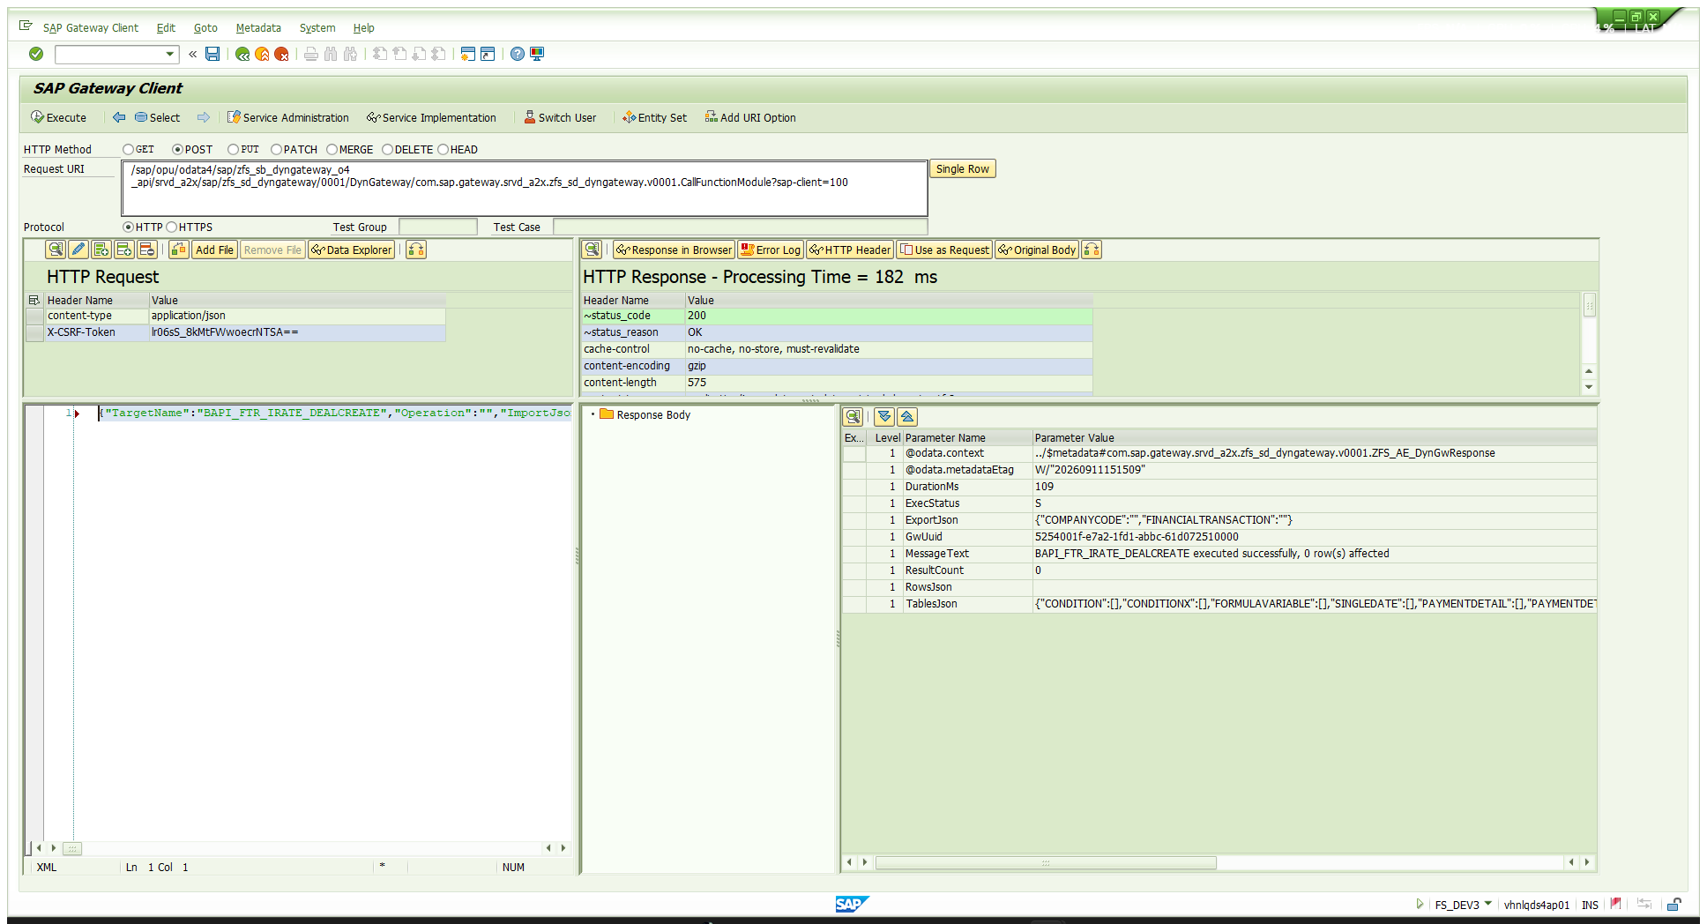
05-TC03-testrun-request.png — TC-03 request — TESTRUN='X'
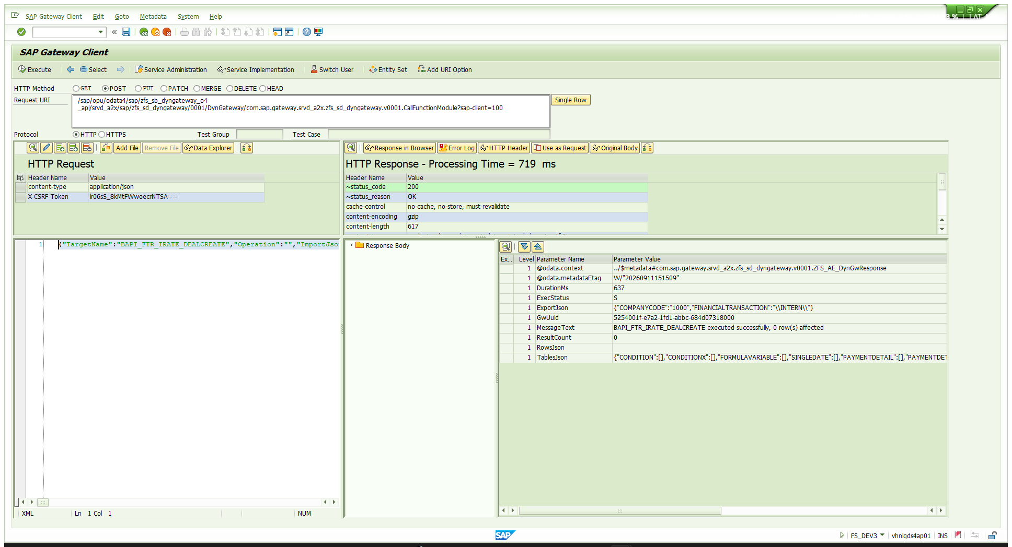
06-TC03-testrun-response-INTERN.png — TC-03 response — \INTERN\ placeholder, the signature of a clean dry run

TC-04 · The real create — ExecuteBatch with CommitMode
Purpose: actually create the deal. This step must be a batch. CallFunctionModule runs the function module and then throws the work away — nothing issues BAPI_TRANSACTION_COMMIT. ExecuteBatch shares one DESTINATION 'NONE' session across its FUNC steps and commits them together according to CommitMode.
Action:
POST /sap/opu/odata4/sap/zfs_sb_dyngateway_o4_api/srvd_a2x/sap/zfs_sd_dyngateway/0001/DynGateway/com.sap.gateway.srvd_a2x.zfs_sd_dyngateway.v0001.ExecuteBatch?sap-client=100
Request body (paste this) — identical to TC-03 except TESTRUN is now empty and the call is wrapped as a batch step with CommitMode=AUTO:
{"TargetName":"","Operation":"","ImportJson":"","TablesJson":"","FieldsJson":"","FilterJson":"","OrderByJson":"","MaxRows":0,"StepsJson":"[{\"Kind\":\"FUNC\",\"TargetName\":\"BAPI_FTR_IRATE_DEALCREATE\",\"ImportJson\":\"{\\\"GENERALCONTRACTDATA\\\":{\\\"COMPANY_CODE\\\":\\\"1000\\\",\\\"PRODUCT_TYPE\\\":\\\"22A\\\",\\\"TRANSACTION_TYPE\\\":\\\"100\\\",\\\"PARTNER\\\":\\\"0700000453\\\",\\\"CONTRACT_DATE\\\":\\\"2026-01-01\\\",\\\"VALUATION_CLASS\\\":\\\"0001\\\"},\\\"GENERALCONTRACTDATAX\\\":{\\\"COMPANY_CODE\\\":\\\"X\\\",\\\"PRODUCT_TYPE\\\":\\\"X\\\",\\\"TRANSACTION_TYPE\\\":\\\"X\\\",\\\"PARTNER\\\":\\\"X\\\",\\\"CONTRACT_DATE\\\":\\\"X\\\",\\\"VALUATION_CLASS\\\":\\\"X\\\"},\\\"INTERESTRATEINSTRUMENT\\\":{\\\"CURRENCY\\\":\\\"INR\\\",\\\"START_TERM\\\":\\\"2026-01-01\\\",\\\"END_TERM\\\":\\\"2026-12-31\\\",\\\"NOMINAL_AMOUNT\\\":100000,\\\"INTEREST_RATE_STRUCTURE\\\":\\\"1\\\",\\\"INTEREST_CONDITION_TYPE\\\":\\\"1200\\\",\\\"INTEREST_RATE\\\":10,\\\"INTEREST_CALC_METH\\\":\\\"3\\\",\\\"FREQUENCY_CATEGORY\\\":\\\"3\\\",\\\"FREQUENCY\\\":1,\\\"FREQUENCY_UNIT\\\":\\\"2\\\",\\\"INTEREST_CALENDAR_ID\\\":\\\"01\\\",\\\"EFFECTIVE_FROM\\\":\\\"2026-01-01\\\",\\\"REPAY_STRUCTURE\\\":\\\"1\\\",\\\"REPAY_CONDITION_TYPE\\\":\\\"1120\\\"},\\\"INTERESTRATEINSTRUMENTX\\\":{\\\"CURRENCY\\\":\\\"X\\\",\\\"START_TERM\\\":\\\"X\\\",\\\"END_TERM\\\":\\\"X\\\",\\\"NOMINAL_AMOUNT\\\":\\\"X\\\",\\\"INTEREST_RATE_STRUCTURE\\\":\\\"X\\\",\\\"INTEREST_CONDITION_TYPE\\\":\\\"X\\\",\\\"INTEREST_RATE\\\":\\\"X\\\",\\\"INTEREST_CALC_METH\\\":\\\"X\\\",\\\"FREQUENCY_CATEGORY\\\":\\\"X\\\",\\\"FREQUENCY\\\":\\\"X\\\",\\\"FREQUENCY_UNIT\\\":\\\"X\\\",\\\"INTEREST_CALENDAR_ID\\\":\\\"X\\\",\\\"EFFECTIVE_FROM\\\":\\\"X\\\",\\\"REPAY_STRUCTURE\\\":\\\"X\\\",\\\"REPAY_CONDITION_TYPE\\\":\\\"X\\\"},\\\"TESTRUN\\\":\\\"\\\"}\",\"TablesJson\":\"{\\\"CONDITION\\\":[],\\\"CONDITIONX\\\":[],\\\"FORMULAVARIABLE\\\":[],\\\"SINGLEDATE\\\":[],\\\"PAYMENTDETAIL\\\":[],\\\"PAYMENTDETAILX\\\":[],\\\"ADDFLOW\\\":[],\\\"ADDFLOWX\\\":[],\\\"MAINFLOW\\\":[],\\\"MAINFLOWX\\\":[],\\\"RETURN\\\":[]}\"}]","CommitMode":"AUTO"}
Expected | ExecStatus='S' and a real transaction number in FINANCIALTRANSACTION
Actual | HTTP 200 · ExecStatus=S · ResultCount=1 · DurationMs=1359  step 1 FUNC BAPI_FTR_IRATE_DEALCREATE EXECSTATUS=S (856 ms)  EXPORTJSON: {"COMPANYCODE":"1000","FINANCIALTRANSACTION":"0000000160445"}  RETURN: W FTR_GUI 220 (partner warning) · I FTR0 162 "BAPI was executed successfully"  GwUuid: 5254001f-e7a2-1fd1-abbc-6e0e74294000
Table effect | Two more rows — a BTCH parent (1359 ms) and its FUNC child (STEP_INDEX=1, PHASE='X', 856 ms). The deal number is recorded in the child row's RESPONSE_JSON; ROW_COUNT stays 0 because BAPIs report no row count.
Verdict | PASS — deal 0000000160445

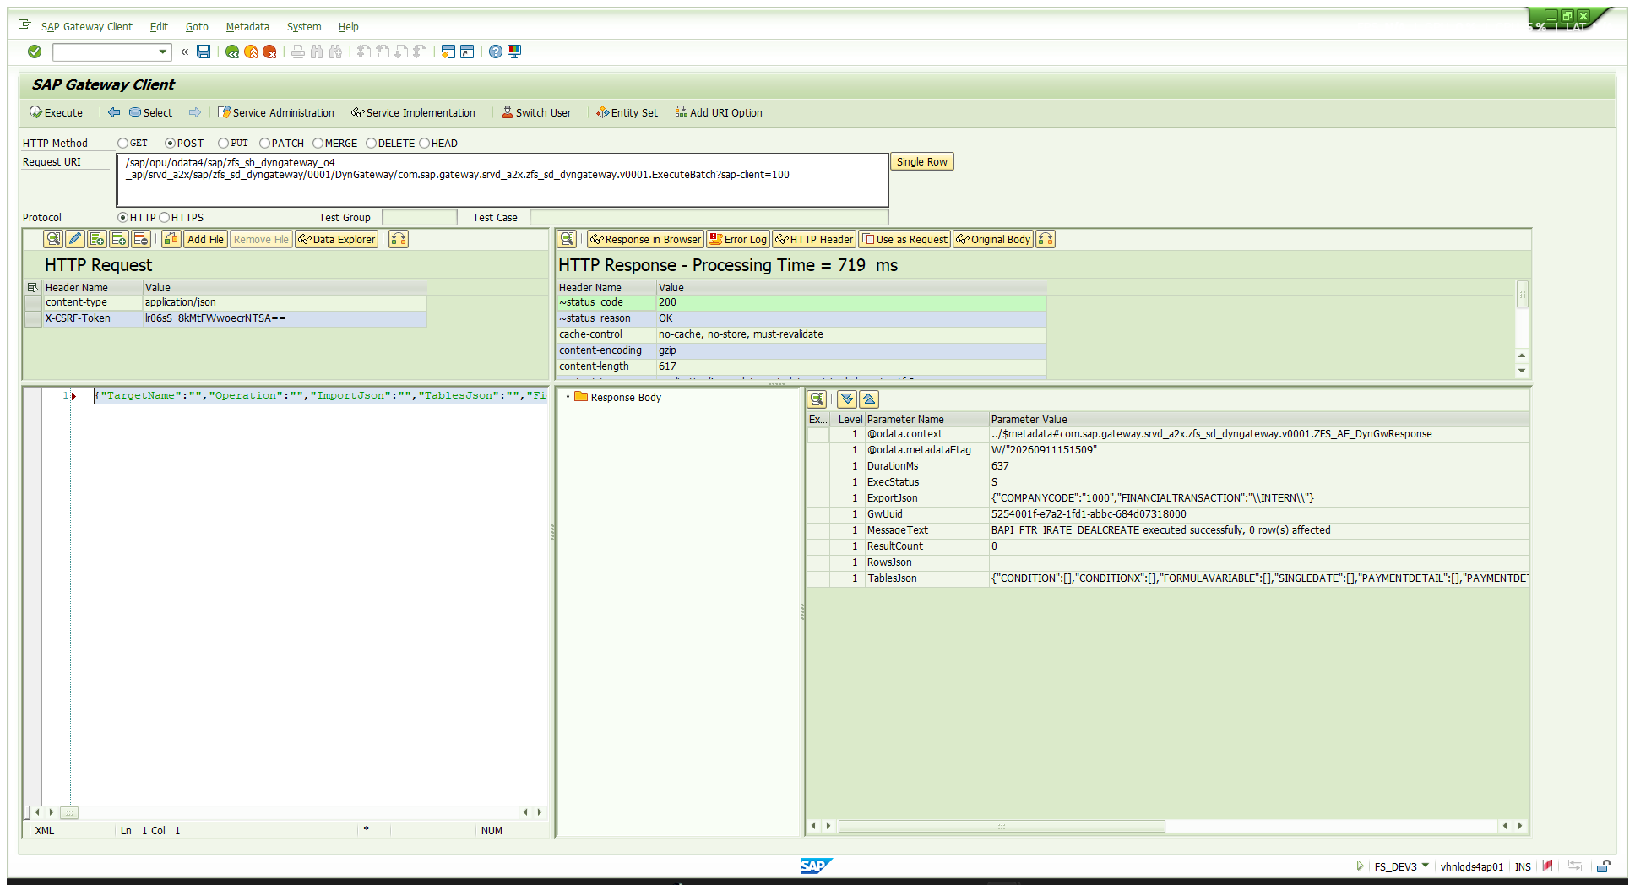
07-TC04-create-request.png — TC-04 request — the committing call
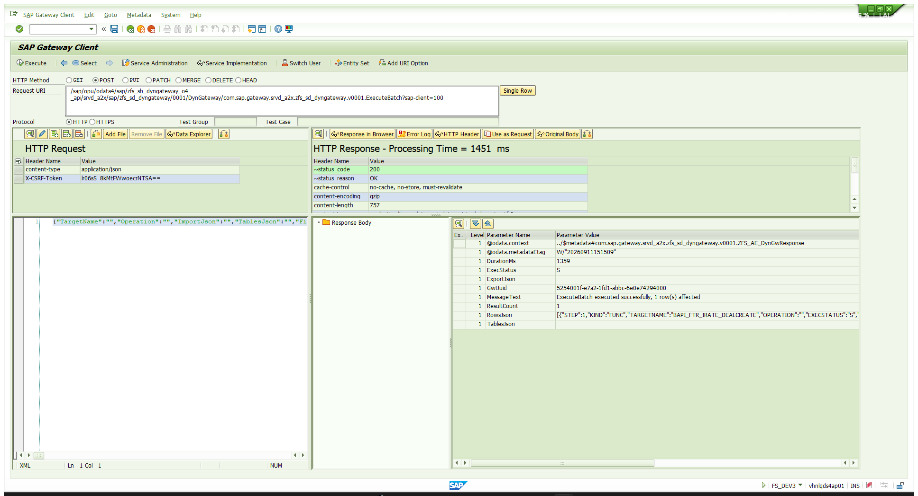
08-TC04-create-response.png — TC-04 response — ExecStatus S, one step, one row affected

TC-05 · Register a target and use it in the SAME call
Purpose: the feature that makes REGI worth having. VTBFHA is not in the allow-list when this request is sent, yet step 2 reads it successfully. ExecuteBatch validates every step before any step executes, and REGI publishes its intent into the same per-request buffer the registry uses — so step 2 resolves against "committed rows plus what earlier REGI steps in this batch declared".
Action:
POST /sap/opu/odata4/sap/zfs_sb_dyngateway_o4_api/srvd_a2x/sap/zfs_sd_dyngateway/0001/DynGateway/com.sap.gateway.srvd_a2x.zfs_sd_dyngateway.v0001.ExecuteBatch?sap-client=100
Request body (paste this):
{"TargetName":"","Operation":"","ImportJson":"","TablesJson":"","FieldsJson":"","FilterJson":"","OrderByJson":"","MaxRows":0,"StepsJson":"[{\"Kind\":\"REGI\",\"TargetName\":\"VTBFHA\",\"Operation\":\"INSERT\",\"ImportJson\":\"{\\\"TargetKind\\\":\\\"QURY\\\",\\\"Operation\\\":\\\"SELECT\\\",\\\"IsActive\\\":\\\"X\\\",\\\"AllowRead\\\":\\\"X\\\",\\\"AllowWrite\\\":\\\"\\\",\\\"MaxRows\\\":20,\\\"Descr\\\":\\\"FTR transaction header - verification read\\\"}\"},{\"Kind\":\"QURY\",\"TargetName\":\"VTBFHA\",\"FieldsJson\":\"[\\\"BUKRS\\\", \\\"RFHA\\\", \\\"SGSART\\\", \\\"SFHAART\\\", \\\"KONTRH\\\", \\\"WGSCHFT\\\", \\\"RCOMVALCL\\\", \\\"DBLFZ\\\", \\\"DELFZ\\\", \\\"DCRDAT\\\"]\",\"OrderByJson\":\"[{\\\"Field\\\": \\\"RFHA\\\", \\\"Descending\\\": true}]\",\"MaxRows\":5}]","CommitMode":"NEVER"}
Expected | Both steps ExecStatus='S'
Actual | HTTP 200 · ExecStatus=S · ResultCount=2 · DurationMs=308  step 1 REGI VTBFHA INSERT → S, 1 row affected (2 ms)  step 2 QURY VTBFHA → S, 5 rows (43 ms)
Note | The 5 rows are the top of VTBFHA sorted by RFHA descending across all company codes, so they are company code 9990's deals — our deal is read explicitly in TC-06.
Table effect | Four more rows: the VTBFHA registry row, a BTCH parent, and two children (STEP_INDEX 1 and 2, both PHASE='X').
Verdict | PASS

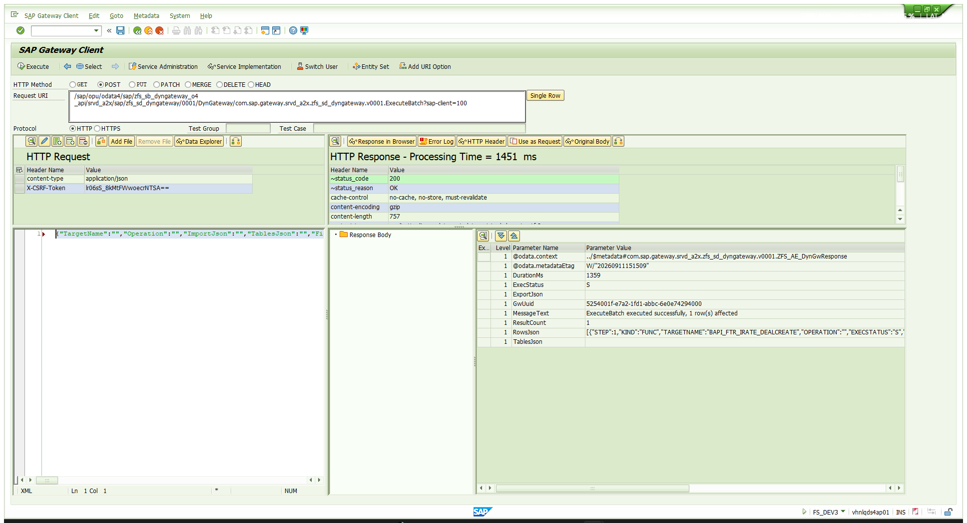
09-TC05-verify-request.png — TC-05 request — REGI then QURY on the same target
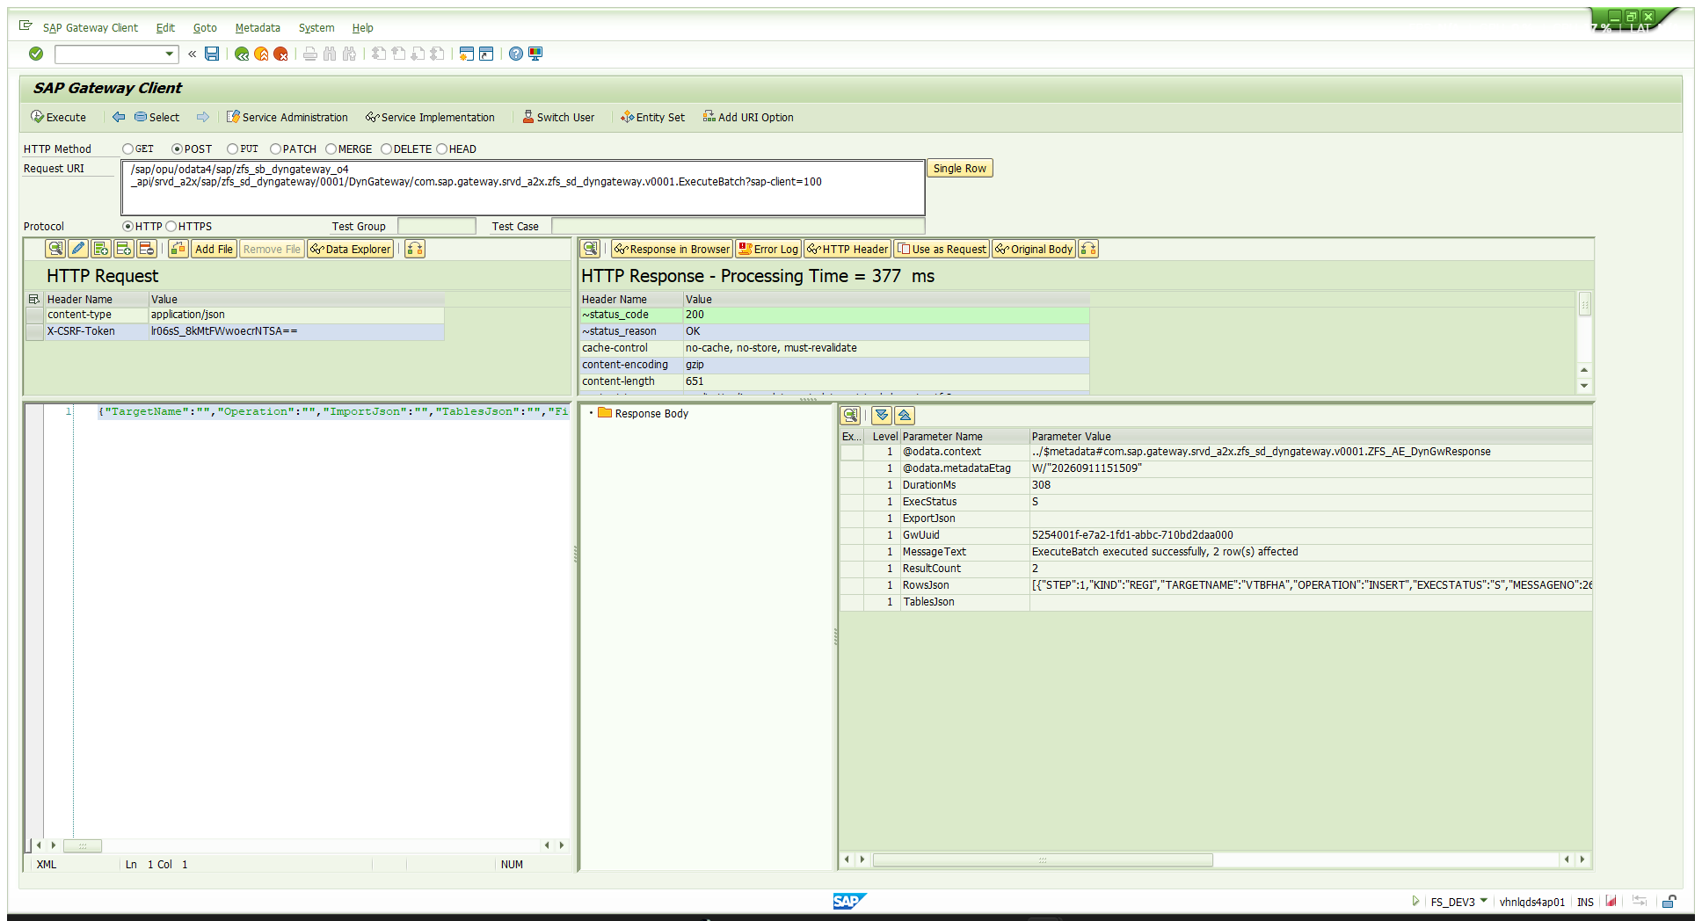
10-TC05-verify-response.png — TC-05 response — both steps S, 2 rows affected

TC-06 · Reading the new deal back through the gateway
Purpose: confirm the created deal over the same OData service that created it.
Action:
POST /sap/opu/odata4/sap/zfs_sb_dyngateway_o4_api/srvd_a2x/sap/zfs_sd_dyngateway/0001/DynGateway/com.sap.gateway.srvd_a2x.zfs_sd_dyngateway.v0001.RunQuery?sap-client=100
Request body (paste this):
{"TargetName":"VTBFHA","Operation":"","ImportJson":"","TablesJson":"","FieldsJson":"[\"BUKRS\", \"RFHA\", \"SGSART\", \"SFHAART\", \"KONTRH\", \"WGSCHFT\", \"RCOMVALCL\", \"DBLFZ\", \"DELFZ\", \"DCRDAT\"]","FilterJson":"[{\"Field\": \"BUKRS\", \"Op\": \"EQ\", \"Low\": \"1000\", \"High\": \"\"}, {\"Field\": \"RFHA\", \"Op\": \"EQ\", \"Low\": \"0000000160445\", \"High\": \"\"}]","OrderByJson":"","MaxRows":5,"StepsJson":"","CommitMode":""}
Always send FieldsJson against an SAP-standard table: field validation does not flatten DDIC .INCLUDEs, so the all-columns default breaks on such tables.
Expected | ExecStatus='S', exactly one row, our deal
Actual | HTTP 200 · ExecStatus=S · ResultCount=1 · DurationMs=22  RowsJson: [{"BUKRS":"1000","RFHA":"0000000160445","SGSART":"22A",  "SFHAART":"100","KONTRH":"0700000453","WGSCHFT":"INR",  "RCOMVALCL":1,"DBLFZ":"2026-01-01","DELFZ":"2026-12-31",  "DCRDAT":"2026-09-11"}]
Verdict | PASS

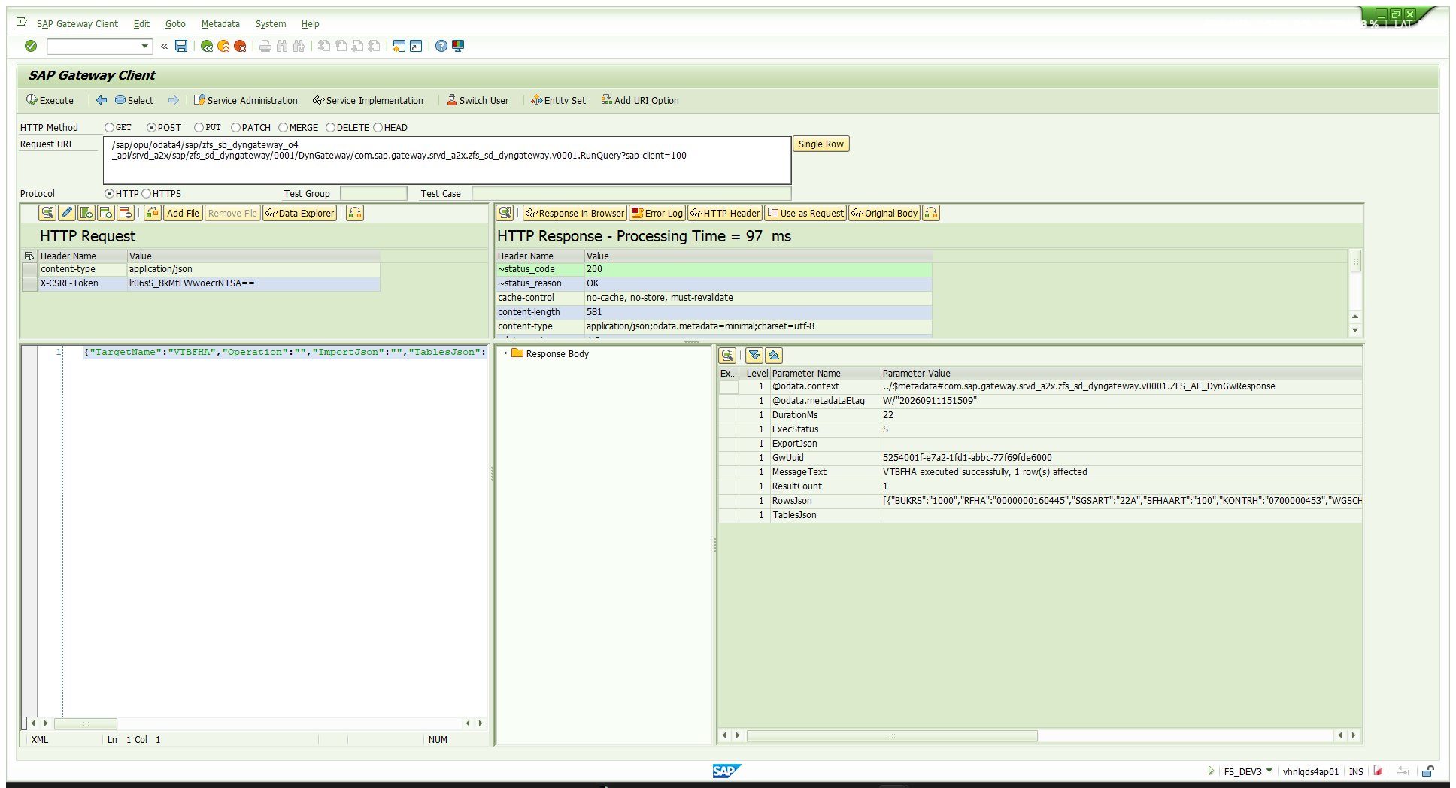
11-TC06-readback-deal-160445.png — TC-06 response — the deal read back over OData

7 · Business verification — is it really the deal that was asked for?
The gateway said it created a deal. This section checks the deal itself, independently, against the database.

7.1 · Header — VTBFHA
Field | Value | Matches the test case?
BUKRS | 1000 | yes — company code 1000
RFHA | 0000000160445 | the new transaction
SGSART | 22A | yes — product type 22A
SFHAART | 100 | yes — transaction type 100
KONTRH | 0700000453 | yes — partner 700000453, stored zero-padded
WGSCHFT | INR | yes
DBLFZ | 01.01.2026 | yes — start of term
DELFZ | 31.12.2026 | yes — end of term
RCOMVALCL | 1 | valuation class, mandatory on this system
DCRDAT | 11.09.2026 | created today

7.2 · Conditions — VTBFINKO — this is the monthly-interest proof
The nominal amount and the 10 % rate are easy to see. "Monthly" is the part worth checking properly, and it shows up two ways: in the rhythm fields, and in the first due date.
Field | Interest condition | Repayment condition | Meaning
RKOND | 1000 | 2000 | condition number
SKOART | 1200 | 1120 | condition type — interest / final repayment
PKOND | 10.0000000 | 100.0000000 | 10 % interest · 100 % of nominal repaid
SRHYTHM | 3 | 1 | 3 = MONTHLY · 1 = one-off
AMMRHY | 001 | 000 | every 1 period · not recurring
DGUEL_KP | 01.01.2026 | 01.01.2026 | effective from
DFAELL | 01.02.2026 | 31.12.2026 | first interest due one month after start · bullet at end
SZBMETH | 3 | 3 | interest calculation method

SRHYTHM = 3 with AMMRHY = 001 is monthly, and the derived first interest due date of 01.02.2026 — exactly one month after the 01.01.2026 start of term — confirms it independently. The repayment condition is a single 100 % flow on 31.12.2026, i.e. bullet.
Note the CONDITION, MAINFLOW and PAYMENTDETAIL tables were all sent EMPTY. The system derived both conditions from the wizard-style fields in INTERESTRATEINSTRUMENT (INTEREST_RATE_STRUCTURE, FREQUENCY_CATEGORY, FREQUENCY, FREQUENCY_UNIT, REPAY_STRUCTURE).
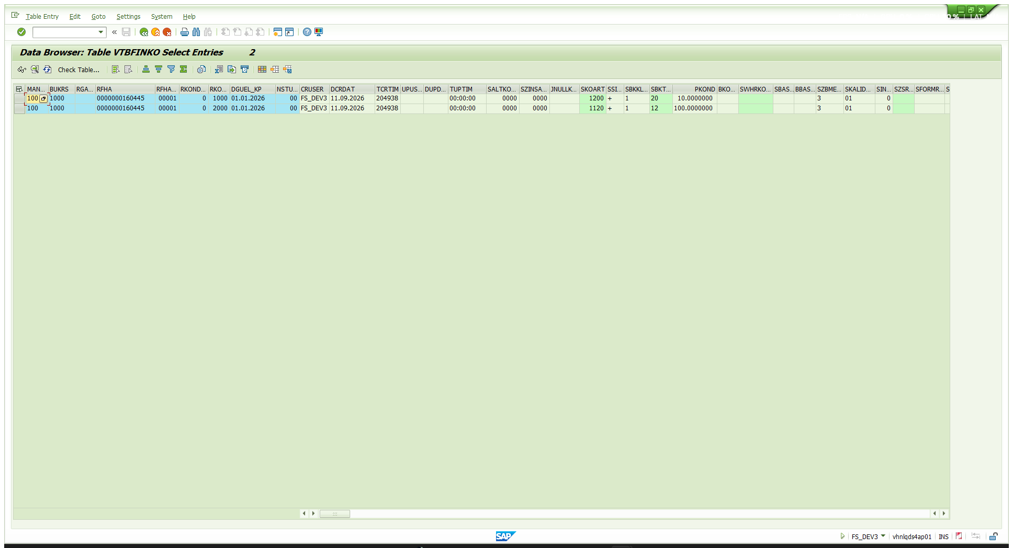
12-VTBFINKO-conditions-monthly.png — VTBFINKO — interest condition 1200 at 10 % monthly, repayment condition 1120 at 100 % on 31.12.2026

8 · What the table looked like after every step
The registry started empty and finished with 13 rows — 2 registry rows and 11 call-log rows. This is the whole run, in order.
# | Type | Kind | Target | Step | Phase | St | Msg | ms | Written by
1 | L | FUNC | BAPI_FTR_IRATE_DEALCREATE | 0 |  | E | 017 | 722 | TC-01 refusal
2 | R | FUNC | BAPI_FTR_IRATE_DEALCREATE | 0 |  |  |  | 0 | TC-02 registry row
3 | L | BTCH | (blank) | 0 |  | S | 026 | 208 | TC-02 batch parent
4 | L | REGI | BAPI_FTR_IRATE_DEALCREATE | 1 | X | S | 026 | 4 | TC-02 batch child
5 | L | FUNC | BAPI_FTR_IRATE_DEALCREATE | 0 |  | S | 026 | 109 | dry run without X structures (failed in RETURN)
6 | L | FUNC | BAPI_FTR_IRATE_DEALCREATE | 0 |  | S | 026 | 637 | TC-03 dry run, corrected
7 | L | BTCH | (blank) | 0 |  | S | 026 | 1359 | TC-04 batch parent
8 | L | FUNC | BAPI_FTR_IRATE_DEALCREATE | 1 | X | S | 026 | 856 | TC-04 — THE CREATE
9 | R | QURY | VTBFHA | 0 |  |  |  | 0 | TC-05 registry row
10 | L | BTCH | (blank) | 0 |  | S | 026 | 308 | TC-05 batch parent
11 | L | REGI | VTBFHA | 1 | X | S | 026 | 2 | TC-05 child step 1
12 | L | QURY | VTBFHA | 2 | X | S | 026 | 43 | TC-05 child step 2
13 | L | QURY | VTBFHA | 0 |  | S | 026 | 22 | TC-06 read-back

Counting calls: filter STEP_INDEX = 0 for one row per call, or PHASE = 'X' for one row per batch step. Counting ENTRY_TYPE='L' alone double-counts every batch.
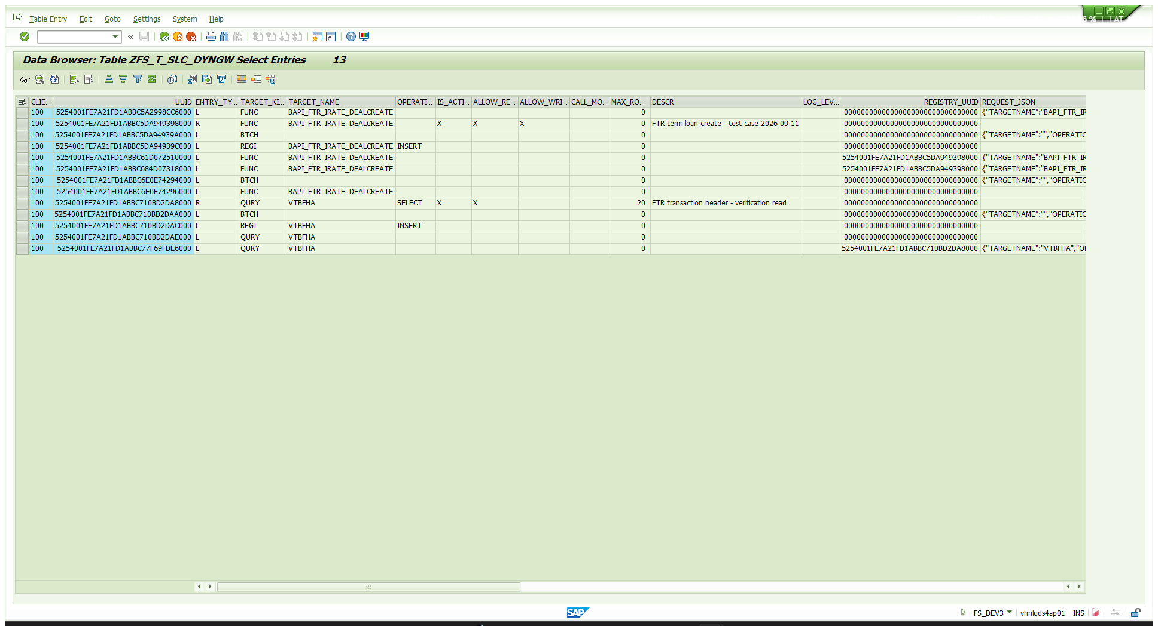
13-final-table-13-rows.png — ZFS_T_SLC_DYNGW after the run — 13 rows

8.1 · What each row shape actually stores
REQUEST_JSON and RESPONSE_JSON are filled asymmetrically. This matters if you rely on the table for audit.
Row shape | REQUEST_JSON | RESPONSE_JSON
single-shot FUNC (STEP_INDEX=0) | full action payload | ExportJson + TablesJson
single-shot QURY (STEP_INDEX=0) | full action payload | EMPTY — the rows are not kept
batch parent (BTCH) | full payload incl. StepsJson | the per-step array
batch child (STEP_INDEX≥1, PHASE='X') | EMPTY | that step's own result

For a batch nothing is lost — parent carries the request, child carries the response. But the rows returned by a single-shot RunQuery are not retained anywhere, so "what did this query hand out?" cannot be answered afterwards even though ROW_COUNT is set. If a read matters for audit, run it as a one-step ExecuteBatch instead.

9 · Pitfalls — what actually goes wrong
Every item here was hit for real, either in this run or an earlier one on the same service.
Symptom | Cause | Fix
BAPI returns "Product type not defined" for a product type you DID send (note the blank in the message) | BAPI_FTR_IRATE_DEALCREATE is a "complete create" BAPI — a value is ignored unless its X change-indicator flag is set | Send GENERALCONTRACTDATAX and INTERESTRATEINSTRUMENTX, mirroring each supplied field with "X". BAPI_FTR_IRATE_CREATE has no X structures and does not need them — do not copy one BAPI's payload to the other.
R1 201 "Business partner 700000453 does not exist" | The gateway applies NO conversion exits — values are bound straight onto DDIC fields | Send the INTERNAL, zero-padded form: "0700000453". Same for customers, vendors, G/L accounts, material numbers — anything with an ALPHA exit.
A NUMC field loses its leading zeros | It was sent as a JSON number | Send NUMC as a quoted string: "VALUATION_CLASS": "0001", never 1.
A CURR or DEC field is refused | It was sent as a quoted string | Send amounts and rates as unquoted numbers: 100000, not "100000".
The FM "returns nothing" | Its output-only TABLES parameter was not named, so it was never bound | Send it as an empty array: "TablesJson":"{\"RETURN\":[]}".
A creating BAPI reports S but nothing was created | CallFunctionModule never commits | Use ExecuteBatch with a CommitMode.
ExecStatus=S but the data is wrong | ExecStatus is the dispatch, not the business outcome | Parse RETURN; treat any E or A row as a failure.
Every call answers 017 on a newly imported system | Allow-list rows are delivery class A — they do not travel with the transport | Register the targets on that system; a single ExecuteBatch of REGI steps does the lot.
022 "Invalid JSON in parameter …" and it will not say which level | Hand-escaping three levels of nested JSON | Build innermost-first and let the serialiser escape. Never hand-type level 3.
Contract date is after start of term | CONTRACT_DATE defaults to today, which is after a back-dated START_TERM | Set CONTRACT_DATE explicitly — here 2026-01-01.
400 CX_SXML_PARSE_ERROR from the Gateway Client | The body pane defaults to XML | Add content-type = application/json to the HTTP Request header grid.

10 · What was left on the system
Registry rows (ENTRY_TYPE='R'), both active:
Target | Kind | Operation | Active | Read | Write | MaxRows | Descr
BAPI_FTR_IRATE_DEALCREATE | FUNC | (any) | X | X | X | 0 | FTR term loan create - test case 2026-09-11
VTBFHA | QURY | SELECT | X | X | — | 20 | FTR transaction header - verification read

Business data: FTR transaction 0000000160445 in company code 1000, with its two conditions in VTBFINKO. It has not been settled and nothing has been posted.
OPEN RISK: the BAPI_FTR_IRATE_DEALCREATE row carries ALLOW_WRITE='X' and IS_ACTIVE='X', so any caller who can reach this service can create FTR deals on DS4/100. Clearing IS_ACTIVE is an instant kill switch — no transport, no restart — and is the right action once this testing is finished.

10.1 · Turning it off
PATCH /sap/opu/odata4/sap/zfs_sb_dyngateway_o4_api/srvd_a2x/sap/zfs_sd_dyngateway/0001/DynGateway(<GwUuid>)?sap-client=100
If-Match: *
{ "IsActive": "" }
DELETE /sap/opu/odata4/sap/zfs_sb_dyngateway_o4_api/srvd_a2x/sap/zfs_sd_dyngateway/0001/DynGateway(<GwUuid>)?sap-client=100
If-Match: *
Find the GwUuid with:
GET /sap/opu/odata4/sap/zfs_sb_dyngateway_o4_api/srvd_a2x/sap/zfs_sd_dyngateway/0001/DynGateway?sap-client=100&$filter=EntryType eq 'R'&$select=GwUuid,TargetName,TargetKind,IsActive

11 · Reference — the paste-ready payloads
All six request bodies in one place, exactly as they go into the body pane of /IWFND/GW_CLIENT. Each is one line.
TC-01 — refusal (BAPI not yet registered)
URI: /sap/opu/odata4/sap/zfs_sb_dyngateway_o4_api/srvd_a2x/sap/zfs_sd_dyngateway/0001/DynGateway/com.sap.gateway.srvd_a2x.zfs_sd_dyngateway.v0001.CallFunctionModule?sap-client=100
{"TargetName":"BAPI_FTR_IRATE_DEALCREATE","Operation":"","ImportJson":"{\"GENERALCONTRACTDATA\":{\"COMPANY_CODE\":\"1000\",\"PRODUCT_TYPE\":\"22A\",\"TRANSACTION_TYPE\":\"100\",\"PARTNER\":\"0700000453\",\"CONTRACT_DATE\":\"2026-01-01\",\"VALUATION_CLASS\":\"0001\"},\"GENERALCONTRACTDATAX\":{\"COMPANY_CODE\":\"X\",\"PRODUCT_TYPE\":\"X\",\"TRANSACTION_TYPE\":\"X\",\"PARTNER\":\"X\",\"CONTRACT_DATE\":\"X\",\"VALUATION_CLASS\":\"X\"},\"INTERESTRATEINSTRUMENT\":{\"CURRENCY\":\"INR\",\"START_TERM\":\"2026-01-01\",\"END_TERM\":\"2026-12-31\",\"NOMINAL_AMOUNT\":100000,\"INTEREST_RATE_STRUCTURE\":\"1\",\"INTEREST_CONDITION_TYPE\":\"1200\",\"INTEREST_RATE\":10,\"INTEREST_CALC_METH\":\"3\",\"FREQUENCY_CATEGORY\":\"3\",\"FREQUENCY\":1,\"FREQUENCY_UNIT\":\"2\",\"INTEREST_CALENDAR_ID\":\"01\",\"EFFECTIVE_FROM\":\"2026-01-01\",\"REPAY_STRUCTURE\":\"1\",\"REPAY_CONDITION_TYPE\":\"1120\"},\"INTERESTRATEINSTRUMENTX\":{\"CURRENCY\":\"X\",\"START_TERM\":\"X\",\"END_TERM\":\"X\",\"NOMINAL_AMOUNT\":\"X\",\"INTEREST_RATE_STRUCTURE\":\"X\",\"INTEREST_CONDITION_TYPE\":\"X\",\"INTEREST_RATE\":\"X\",\"INTEREST_CALC_METH\":\"X\",\"FREQUENCY_CATEGORY\":\"X\",\"FREQUENCY\":\"X\",\"FREQUENCY_UNIT\":\"X\",\"INTEREST_CALENDAR_ID\":\"X\",\"EFFECTIVE_FROM\":\"X\",\"REPAY_STRUCTURE\":\"X\",\"REPAY_CONDITION_TYPE\":\"X\"},\"TESTRUN\":\"X\"}","TablesJson":"{\"CONDITION\":[],\"CONDITIONX\":[],\"FORMULAVARIABLE\":[],\"SINGLEDATE\":[],\"PAYMENTDETAIL\":[],\"PAYMENTDETAILX\":[],\"ADDFLOW\":[],\"ADDFLOWX\":[],\"MAINFLOW\":[],\"MAINFLOWX\":[],\"RETURN\":[]}","FieldsJson":"","FilterJson":"","OrderByJson":"","MaxRows":0,"StepsJson":"","CommitMode":""}
TC-02 — register the BAPI
URI: /sap/opu/odata4/sap/zfs_sb_dyngateway_o4_api/srvd_a2x/sap/zfs_sd_dyngateway/0001/DynGateway/com.sap.gateway.srvd_a2x.zfs_sd_dyngateway.v0001.ExecuteBatch?sap-client=100
{"TargetName":"","Operation":"","ImportJson":"","TablesJson":"","FieldsJson":"","FilterJson":"","OrderByJson":"","MaxRows":0,"StepsJson":"[{\"Kind\":\"REGI\",\"TargetName\":\"BAPI_FTR_IRATE_DEALCREATE\",\"Operation\":\"INSERT\",\"ImportJson\":\"{\\\"TargetKind\\\":\\\"FUNC\\\",\\\"Operation\\\":\\\"\\\",\\\"IsActive\\\":\\\"X\\\",\\\"AllowRead\\\":\\\"X\\\",\\\"AllowWrite\\\":\\\"X\\\",\\\"CallMode\\\":\\\"\\\",\\\"MaxRows\\\":0,\\\"Descr\\\":\\\"FTR term loan create - test case 2026-09-11\\\"}\"}]","CommitMode":"AUTO"}
TC-03 — dry run, TESTRUN='X'
URI: /sap/opu/odata4/sap/zfs_sb_dyngateway_o4_api/srvd_a2x/sap/zfs_sd_dyngateway/0001/DynGateway/com.sap.gateway.srvd_a2x.zfs_sd_dyngateway.v0001.CallFunctionModule?sap-client=100
{"TargetName":"BAPI_FTR_IRATE_DEALCREATE","Operation":"","ImportJson":"{\"GENERALCONTRACTDATA\":{\"COMPANY_CODE\":\"1000\",\"PRODUCT_TYPE\":\"22A\",\"TRANSACTION_TYPE\":\"100\",\"PARTNER\":\"0700000453\",\"CONTRACT_DATE\":\"2026-01-01\",\"VALUATION_CLASS\":\"0001\"},\"GENERALCONTRACTDATAX\":{\"COMPANY_CODE\":\"X\",\"PRODUCT_TYPE\":\"X\",\"TRANSACTION_TYPE\":\"X\",\"PARTNER\":\"X\",\"CONTRACT_DATE\":\"X\",\"VALUATION_CLASS\":\"X\"},\"INTERESTRATEINSTRUMENT\":{\"CURRENCY\":\"INR\",\"START_TERM\":\"2026-01-01\",\"END_TERM\":\"2026-12-31\",\"NOMINAL_AMOUNT\":100000,\"INTEREST_RATE_STRUCTURE\":\"1\",\"INTEREST_CONDITION_TYPE\":\"1200\",\"INTEREST_RATE\":10,\"INTEREST_CALC_METH\":\"3\",\"FREQUENCY_CATEGORY\":\"3\",\"FREQUENCY\":1,\"FREQUENCY_UNIT\":\"2\",\"INTEREST_CALENDAR_ID\":\"01\",\"EFFECTIVE_FROM\":\"2026-01-01\",\"REPAY_STRUCTURE\":\"1\",\"REPAY_CONDITION_TYPE\":\"1120\"},\"INTERESTRATEINSTRUMENTX\":{\"CURRENCY\":\"X\",\"START_TERM\":\"X\",\"END_TERM\":\"X\",\"NOMINAL_AMOUNT\":\"X\",\"INTEREST_RATE_STRUCTURE\":\"X\",\"INTEREST_CONDITION_TYPE\":\"X\",\"INTEREST_RATE\":\"X\",\"INTEREST_CALC_METH\":\"X\",\"FREQUENCY_CATEGORY\":\"X\",\"FREQUENCY\":\"X\",\"FREQUENCY_UNIT\":\"X\",\"INTEREST_CALENDAR_ID\":\"X\",\"EFFECTIVE_FROM\":\"X\",\"REPAY_STRUCTURE\":\"X\",\"REPAY_CONDITION_TYPE\":\"X\"},\"TESTRUN\":\"X\"}","TablesJson":"{\"CONDITION\":[],\"CONDITIONX\":[],\"FORMULAVARIABLE\":[],\"SINGLEDATE\":[],\"PAYMENTDETAIL\":[],\"PAYMENTDETAILX\":[],\"ADDFLOW\":[],\"ADDFLOWX\":[],\"MAINFLOW\":[],\"MAINFLOWX\":[],\"RETURN\":[]}","FieldsJson":"","FilterJson":"","OrderByJson":"","MaxRows":0,"StepsJson":"","CommitMode":""}
TC-04 — the real create
URI: /sap/opu/odata4/sap/zfs_sb_dyngateway_o4_api/srvd_a2x/sap/zfs_sd_dyngateway/0001/DynGateway/com.sap.gateway.srvd_a2x.zfs_sd_dyngateway.v0001.ExecuteBatch?sap-client=100
{"TargetName":"","Operation":"","ImportJson":"","TablesJson":"","FieldsJson":"","FilterJson":"","OrderByJson":"","MaxRows":0,"StepsJson":"[{\"Kind\":\"FUNC\",\"TargetName\":\"BAPI_FTR_IRATE_DEALCREATE\",\"ImportJson\":\"{\\\"GENERALCONTRACTDATA\\\":{\\\"COMPANY_CODE\\\":\\\"1000\\\",\\\"PRODUCT_TYPE\\\":\\\"22A\\\",\\\"TRANSACTION_TYPE\\\":\\\"100\\\",\\\"PARTNER\\\":\\\"0700000453\\\",\\\"CONTRACT_DATE\\\":\\\"2026-01-01\\\",\\\"VALUATION_CLASS\\\":\\\"0001\\\"},\\\"GENERALCONTRACTDATAX\\\":{\\\"COMPANY_CODE\\\":\\\"X\\\",\\\"PRODUCT_TYPE\\\":\\\"X\\\",\\\"TRANSACTION_TYPE\\\":\\\"X\\\",\\\"PARTNER\\\":\\\"X\\\",\\\"CONTRACT_DATE\\\":\\\"X\\\",\\\"VALUATION_CLASS\\\":\\\"X\\\"},\\\"INTERESTRATEINSTRUMENT\\\":{\\\"CURRENCY\\\":\\\"INR\\\",\\\"START_TERM\\\":\\\"2026-01-01\\\",\\\"END_TERM\\\":\\\"2026-12-31\\\",\\\"NOMINAL_AMOUNT\\\":100000,\\\"INTEREST_RATE_STRUCTURE\\\":\\\"1\\\",\\\"INTEREST_CONDITION_TYPE\\\":\\\"1200\\\",\\\"INTEREST_RATE\\\":10,\\\"INTEREST_CALC_METH\\\":\\\"3\\\",\\\"FREQUENCY_CATEGORY\\\":\\\"3\\\",\\\"FREQUENCY\\\":1,\\\"FREQUENCY_UNIT\\\":\\\"2\\\",\\\"INTEREST_CALENDAR_ID\\\":\\\"01\\\",\\\"EFFECTIVE_FROM\\\":\\\"2026-01-01\\\",\\\"REPAY_STRUCTURE\\\":\\\"1\\\",\\\"REPAY_CONDITION_TYPE\\\":\\\"1120\\\"},\\\"INTERESTRATEINSTRUMENTX\\\":{\\\"CURRENCY\\\":\\\"X\\\",\\\"START_TERM\\\":\\\"X\\\",\\\"END_TERM\\\":\\\"X\\\",\\\"NOMINAL_AMOUNT\\\":\\\"X\\\",\\\"INTEREST_RATE_STRUCTURE\\\":\\\"X\\\",\\\"INTEREST_CONDITION_TYPE\\\":\\\"X\\\",\\\"INTEREST_RATE\\\":\\\"X\\\",\\\"INTEREST_CALC_METH\\\":\\\"X\\\",\\\"FREQUENCY_CATEGORY\\\":\\\"X\\\",\\\"FREQUENCY\\\":\\\"X\\\",\\\"FREQUENCY_UNIT\\\":\\\"X\\\",\\\"INTEREST_CALENDAR_ID\\\":\\\"X\\\",\\\"EFFECTIVE_FROM\\\":\\\"X\\\",\\\"REPAY_STRUCTURE\\\":\\\"X\\\",\\\"REPAY_CONDITION_TYPE\\\":\\\"X\\\"},\\\"TESTRUN\\\":\\\"\\\"}\",\"TablesJson\":\"{\\\"CONDITION\\\":[],\\\"CONDITIONX\\\":[],\\\"FORMULAVARIABLE\\\":[],\\\"SINGLEDATE\\\":[],\\\"PAYMENTDETAIL\\\":[],\\\"PAYMENTDETAILX\\\":[],\\\"ADDFLOW\\\":[],\\\"ADDFLOWX\\\":[],\\\"MAINFLOW\\\":[],\\\"MAINFLOWX\\\":[],\\\"RETURN\\\":[]}\"}]","CommitMode":"AUTO"}
TC-05 — register VTBFHA and read it
URI: /sap/opu/odata4/sap/zfs_sb_dyngateway_o4_api/srvd_a2x/sap/zfs_sd_dyngateway/0001/DynGateway/com.sap.gateway.srvd_a2x.zfs_sd_dyngateway.v0001.ExecuteBatch?sap-client=100
{"TargetName":"","Operation":"","ImportJson":"","TablesJson":"","FieldsJson":"","FilterJson":"","OrderByJson":"","MaxRows":0,"StepsJson":"[{\"Kind\":\"REGI\",\"TargetName\":\"VTBFHA\",\"Operation\":\"INSERT\",\"ImportJson\":\"{\\\"TargetKind\\\":\\\"QURY\\\",\\\"Operation\\\":\\\"SELECT\\\",\\\"IsActive\\\":\\\"X\\\",\\\"AllowRead\\\":\\\"X\\\",\\\"AllowWrite\\\":\\\"\\\",\\\"MaxRows\\\":20,\\\"Descr\\\":\\\"FTR transaction header - verification read\\\"}\"},{\"Kind\":\"QURY\",\"TargetName\":\"VTBFHA\",\"FieldsJson\":\"[\\\"BUKRS\\\", \\\"RFHA\\\", \\\"SGSART\\\", \\\"SFHAART\\\", \\\"KONTRH\\\", \\\"WGSCHFT\\\", \\\"RCOMVALCL\\\", \\\"DBLFZ\\\", \\\"DELFZ\\\", \\\"DCRDAT\\\"]\",\"OrderByJson\":\"[{\\\"Field\\\": \\\"RFHA\\\", \\\"Descending\\\": true}]\",\"MaxRows\":5}]","CommitMode":"NEVER"}
TC-06 — read the deal back
URI: /sap/opu/odata4/sap/zfs_sb_dyngateway_o4_api/srvd_a2x/sap/zfs_sd_dyngateway/0001/DynGateway/com.sap.gateway.srvd_a2x.zfs_sd_dyngateway.v0001.RunQuery?sap-client=100
{"TargetName":"VTBFHA","Operation":"","ImportJson":"","TablesJson":"","FieldsJson":"[\"BUKRS\", \"RFHA\", \"SGSART\", \"SFHAART\", \"KONTRH\", \"WGSCHFT\", \"RCOMVALCL\", \"DBLFZ\", \"DELFZ\", \"DCRDAT\"]","FilterJson":"[{\"Field\": \"BUKRS\", \"Op\": \"EQ\", \"Low\": \"1000\", \"High\": \"\"}, {\"Field\": \"RFHA\", \"Op\": \"EQ\", \"Low\": \"0000000160445\", \"High\": \"\"}]","OrderByJson":"","MaxRows":5,"StepsJson":"","CommitMode":""}

